CHAPTER 29

Sources of the Magnetic Field

1* · Compare the directions of the electric and magnetic forces between two positive charges, which move along parallel paths (a) in the same direction, and (b) in opposite directions.
(a) The electric forces are repulsive; the magnetic forces are attractive (the two charges moving in the same direction act like two currents in the same direction).
(b) The electric forces are again repulsive; the magnetic forces are also repulsive.

2 · At time t = 0, a particle with charge q = 12 μC is located at x = 0, y = 2 m; its velocity at that time is v = 30 m/s i. Find the magnetic field at (a) the origin; (b) x = 0, y = 1 m; (c) x = 0, y = 3 m; and (d) x = 0, y = 4 m.
(a) Use Equ. 29-1; r = –2 m j, v = 30 m/s i  (b) r = –1 m j  (c) r = 1 m j  (d) r = 2 m j | B = 10^{–7}q(v×r)/r³; B = –9×10^{–12} T k  B = –3.6×10^{–11} T k  B = 3.6×10^{–11} T k  B = 9×10^{–12} T k

3 · For the particle in Problem 2, find the magnetic field at (a) x = 1 m, y = 3 m; (b) x = 2 m, y = 2 m; and (c) x = 2 m, y = 3 m.
(a) Use Equ. 29-1; r = 1 m i + 1 m j; v = 30 m/s i  (b) r = 2 m i  (c) r = 2 m i + 1 m j | B = 10^{–7}q(v×r)/r³; B = 1.27×10^{–11} T k  B = 0  B = 3.22×10^{–12} T k

4 · A proton (charge +e) traveling with a velocity of v = 1×10⁴ m/s i + 2×10⁴ m/s j is located at x = 3 m, y = 4 m at some time t. Find the magnetic field at the following positions: (a) x = 2 m, y = 2 m; (b) x = 6 m, y = 4 m; and (c) x = 3 m, y = 6 m.
(a) Use Equ. 29-1; q = 1.6×10^{–19} C; r = (–i –2 j) m;  v = (i + 2j)×10⁴ m/s; B = 10^{–7}q(v×r)/r³;  (b) r = 3 m i  (c) r = 2 m j | B = 0 (v and r are colinear)  B = –3.56×10^{–23} T k  B = 4×10^{–23} T k

5* · An electron orbits a proton at a radius of 5.29×10^{–11} m. What is the magnetic field at the proton due to the orbital motion of the electron?
1. Determine the speed of the electron; mv²/r = ke²/r²  2. Use Equ. 29-1; B = (μ₀e²/4πr²)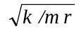; evaluate B | v = 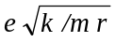  B = 12.5 T

6 ·· Two equal charges q located at (0, 0, 0) and (0, b, 0) at time zero are moving with speed v in the positive x direction (v << c). Find the ratio of the magnitudes of the magnetic and electrostatic force on each.
Note that v and r, where r is the vector from one charge to the other, are at right angles. The field B due to the charge at the origin at the location (0, b, 0) is perpendicular to v and r, i.e., in the z direction, and its magnitude is
B = (μ₀/4π)qv/b². The magnitude of the force on the moving charge at (0, b, 0) is F_{B} = qvB = (μ₀/4π)q²v²/b². Applying the right hand rule the direction of the force is toward the charge at the origin; i.e., the magnetic interaction between the two moving charges is attractive. The electrostatic force is repulsive and of magnitude
F_{E} = (1/4πε₀)q²/b². Thus F_{B}/F_{E} = ε₀μ₀v² = v²/c², where c is the speed of light in vacuum.

7 · The Biot-Savart law is similar to Coulomb's law in that both
(a) are inverse square laws.
(b) deal with forces on charged particles.
(c) deal with excess charges.
(d) include the permeability of free space.
(e) are not electrical in nature.
(a) and (b) are correct.

8 · A small current element I d, with d = 2 mm k and I = 2 A, is centered at the origin. Find the magnetic field dB at the following points: (a) on the x axis at x = 3 m, (b) on the x axis at x = –6 m, (c) on the z axis at z = 3 m, and (d) on the y axis at y = 3 m.
(a) Use Equ. 29-3; I = 2 A, d = 2 mm k, r = 3 m i.  (b) r = –6 m i  (c) r = 3 m k  (d) r = 3 m j | dB = 4.44×10^{–11} T j  dB = –1.11×10^{–11} T j  dB = 0  dB = –4.44×10^{–11} T i

9* · For the current element in Problem 8, find the magnitude and direction of dB at x = 0, y = 3 m, z = 4 m.
Use Equ. 29-3; here r = 3 m j + 4 m k, r = 5 m | dB = -9.6×10⁻¹² T i

10 · For the current element in Problem 8, find the magnitude of dB and indicate its direction on a diagram at (a) x = 2 m, y = 4 m, z = 0 and (b) x = 2 m, y = 0, z = 4 m.

(a) r = (2 i + 4 j) m; dB = 10^{–7}I(d×r)/r³ | dB =(–2i + j)( 8.94×10^{–12} T) | 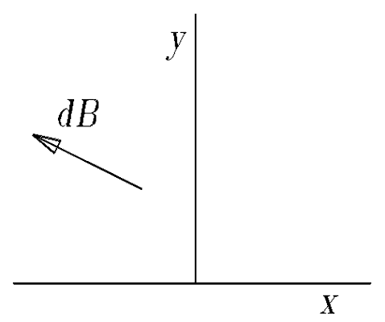

(b) r = (2 i + 4 k) m | dB = 8.94×10^{–12} T j | 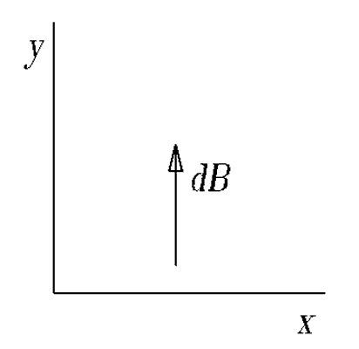

11 · Is B uniform everywhere within a current loop? Explain.
No; the magnitude of the field depends on the location within the loop.

12 · A single loop of wire of radius 3 cm carries a current of 2.6 A. What is the magnitude of B on the axis of the loop at (a) the center of the loop, (b) 1 cm from the center, (c) 2 cm from the center, and (d) 35 cm from the center?

(a) Use Equ. 29-5; x = 0, B = μ₀I/2R
(b) x = 1.0 cm
(c) x = 2.0 cm
(d) x = 35.0 cm
B = 5.45×10^{–5} T
B = 4.65×10^{–5} T
B = 3.14×10^{–5} T
B = 3.39×10^{–8} T

13* · A single-turn, circular loop of radius 10.0 cm is to produce a field at its center that will just cancel the earth's magnetic field at the equator, which is 0.7 G directed north. Find the current in the loop and make a sketch showing the orientation of the loop and the current.
From Equ. 29-5, with x = 0, B = μ₀I/2R; find I | I = 2BR/μ₀ = 2×7×10^{–5}×0.1/4π×10^{–7} A = 11.1 A

The loop is shown in the figure. It is in the vertical  plane and normal to the north direction. The current  is to the west at the top of the loop, to the east at the  bottom of the loop. | 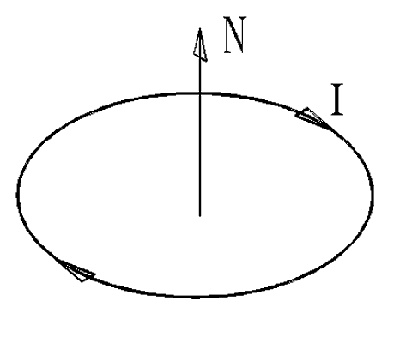

14 ·· For the loop of wire in Problem 13, at what point along the axis of the loop is the magnetic field (a) 10% of the field at the center, (b) 1% of the field at the center, and (c) 0.1% of the field at the center?

(a), (b), (c) From Equ. 29-5, B_{x}/B₀ = R³/(x² + R²)^{3/2}; solve for x; x = R[(B₀/B_{x})^{2/3} – 1]^{1/2}
(a) B₀/B_{x} = 10; x = 19.1 cm; (b) B₀/B_{x} = 100; x = 45.3 cm
(c) B₀/B_{x} = 1000; x = 99.5 cm

15 ·· A single-turn circular loop of radius 8.5 cm is to produce a field at its center that will just cancel the earth's field of magnitude 0.7 G directed at 70° below the horizontal north direction. Find the current in the loop and make a sketch showing the orientation of the loop and the current.
From Equ. 29-5, I = 2RB/μ₀
The normal to the plane of the loop must be in the direction of the earth’s field, and the current must be counterclockwise as seen from above. Here B_{E} denotes the earth’s field and B_{I} the field due to the current in the coil. | I = 9.47 A | 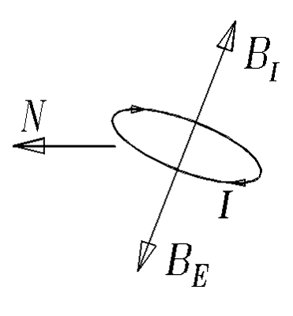

16 ·· A circular current loop of radius R carrying a current I is centered at the origin with its axis along the x axis. Its current is such that it produces a magnetic field in the positive x direction. (a) Sketch a graph of B_{x} versus x for points on the x axis. Include both positive and negative values of x. Compare this graph with that for E_{x} due to a charged ring of the same size. (b) A second, identical current loop, carrying an equal current in the same sense, is in a plane parallel to the yz plane with its center at x = d. Sketch graphs of the magnetic field on the x axis due to each loop separately and the resultant field due to the two loops. Show from your sketch that dB_{x} /dx is zero midway between the two loops.
- The figures below show B(x)/B(0) versus x/R for a loop of radius R carrying a current I and the electric field E(x) versus x/R due to a ring of radius R carrying a total charge Q. Here E(x) is normalized, i.e., we have plotted E(x)/(kQ/R²).
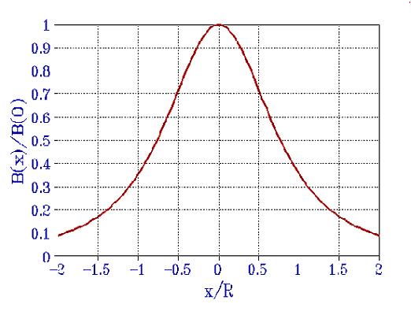 | 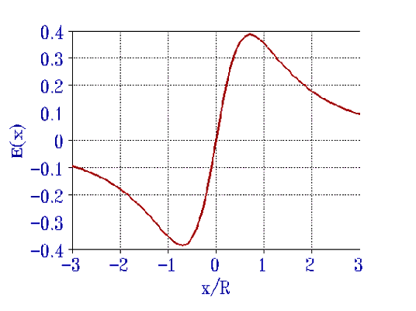

- Here we show three figures for the field as a function of x due to two current-carrying loops where the second loop is displaced by d = 0.5R, d = R, and d = 1.5R from the center of the first loop along the x axis. Note that in
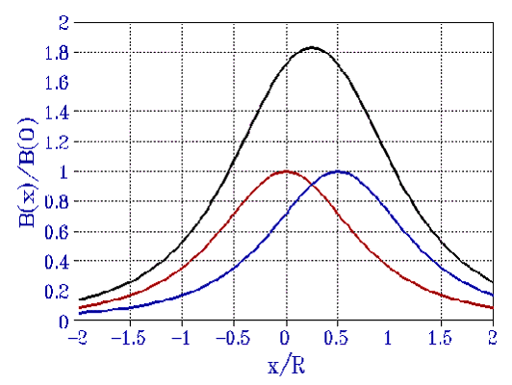 | 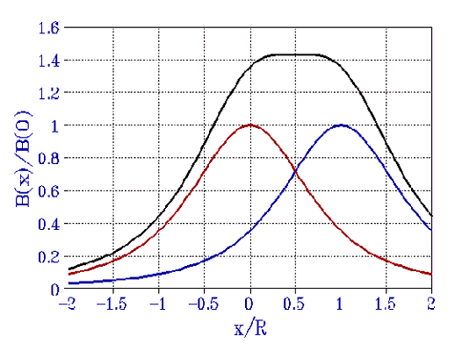
each case, B(x) is a maximum or minimum midway  between the two loops, i.e., dB(x)/dx = 0 at that point. Also, when d = R, B(x) is nearly flat at the midpoint which shows that in the region midway between the two coils B(x) is nearly constant. | 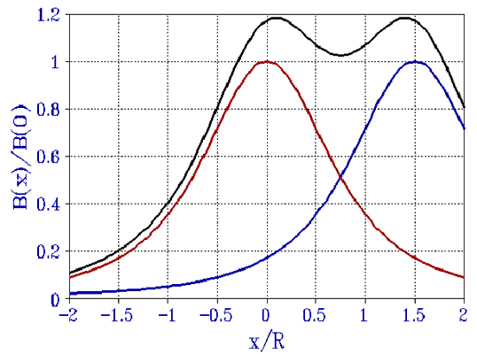

17* ·· Two coils that are separated by a distance equal to their radius and that carry equal currents such that their axial fields add are called Helmholtz coils. A feature of Helmholtz coils is that the resultant magnetic field between the coils is very uniform. Let R = 10 cm, I = 20 A, and N = 300 turns for each coil. Place one coil in the yz plane with its center at the origin and the other in a parallel plane at x = 10 cm. (a) Calculate the resultant field B_{x} at x = 5 cm, x = 7 cm, x = 9 cm, and x = 11 cm. (b) Use your results and the fact that B_{x} is symmetric about the midpoint of the coils to sketch B_{x} versus x. (See also Problem 18.)
- For the coil centered at x = 0, B_{x}(x) is given by Equ. 29-5 multiplied by N, the number of turns. For the coil centered at
x = R, B_{x}(x) = (μ₀R²NI/2)[(x – R)² + R²]^{–3/2}. The total field is  therefore  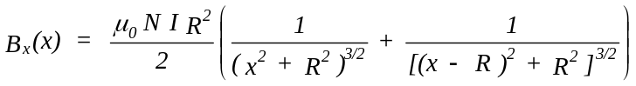  Evaluate B_{x}(x) for N = 300, R = 0.1 m, and I = 20 A at  x = 0.05 m, 0.07 m, 0.09 m, and 0.11 m. One obtains:  B_{x}(0.05) = 0.0540 T, B_{x}(0.07) = 0.0539 T,  B_{x}(0.09) = 0.0526 T, B_{x}(0.11) = 0.0486 T.  (b) B(x) versus x/R is shown in the figure. Note that B is nearly constant between x/R = 0.3 and 0.7. | 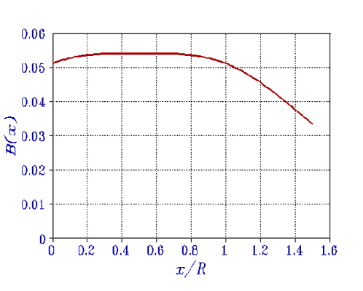

18 ··· Two Helmholtz coils with radii R have their axes along the x axis (see Problem 17). One coil is in the yz plane and the other is in a parallel plane at x = R. Show that at the midpoint of the coils 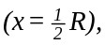0 dB_{x} /dx = 0, d ²B_{x} /dx² = 0, and d ³B_{x} /dx³ = 0. This shows that the magnetic field at points near the midpoint is approximately equal to that at the midpoint.
The field is given by (see preceding problem).
The derivatives of B_{x}(x) with respect to x are as follows:

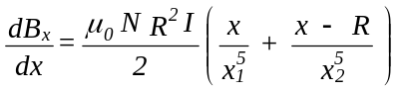; 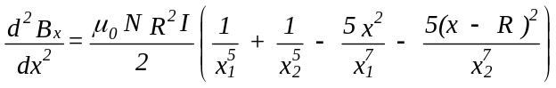

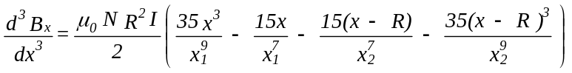. Here 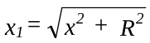 and 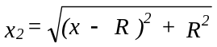.
The midpoint between the two coils is at x = R/2. If we substitute this value in the above expressions, we see that each of the derivatives vanishes.

19 · Two wires lie in the plane of the paper and carry equal currents in opposite directions, as shown in Figure 29-38. At a point midway between the wires, the magnetic field is (a) zero. (b) into the page. (c) out of the page. (d) toward the top or bottom of the page. (e) toward one of the two wires.
(c)

20 · Two parallel wires carry currents I₁ and I₂ = 2I₁ in the same direction. The forces F₁ and F₂ on the wires are related by (a) F₁ = F₂. (b) F₁ = 2F₂. (c) 2F₁ = F₂. (d) F₁ = 4F₂. (e) 4F₁ = F₂.
(a)

21* · A wire carries an electrical current straight up. What is the direction of the magnetic field due to the wire a distance of 2 m north of the wire? (a) North (b) East (c) West (d) South (e) Upward
(c)

22 · Two current-carrying wires are perpendicular to each other. The current in one flows vertically upward and the current in the other flows horizontally toward the east. The horizontal wire is one meter south of the vertical wire. What is the direction of the net magnetic force on the horizontal wire? (a) North (b) East (c) West (d) South (e) There is no net magnetic force on the horizontal wire.
(e)

23 · A long, straight wire carries a current of 10 A. Find the magnitude of B at (a) 10 cm, (b) 50 cm, and (c) 2 m from the center of the wire.
(a), (b), (c) Use Equ. 29-12; B = 2×10^{–7}I/R | (a) B = 2.0×10^{–5} T; (b) B = 4.0×10^{–6} T; (c) B = 1.0×10^{–6} T

Problems 24 to 29 refer to Figure 29-39, which shows two long, straight wires in the xy plane and parallel to the x axis. One wire is at y = –6 cm and the other is at y = +6 cm. The current in each wire is 20 A.

24 · If the currents in Figure 29-39 are in the negative x direction, find B at the points on the y axis at (a) y =
–3 cm, (b) y = 0, (c) y = +3 cm, and (d) y = +9 cm.
(a) Use Equ. 29-12 and the right-hand rule to find B at y = –3 cm due to each wire; we use subscripts – and + for the wires at –6 cm and +6 cm.  (b) At y = 0, B– = –B₊  (c) At y = 3 cm, B = B found in (a)  (d) Proceed as in (a) with y = 9 cm | B– = –(2×10^{–7} ×20/0.03) T k = –1.333×10^{–4} T k;  B₊ = 4.44×10^{–5} T k;  B = B– + B₊; B = –8.89×10^{–5} T k  B = 0  B = 8.89×10^{–5} T k  B– = –2.67×10^{–5} T k; B₊ = –1.333×10^{–4} T k;  B = –1.6×10^{–4} T k

25* · Sketch B_{z} versus y for points on the y axis when both currents are in the negative x direction.
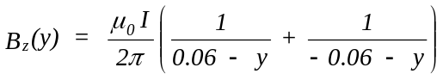

The figure shows B_{y} as a function of y. Here  B is in T, and y in m. | 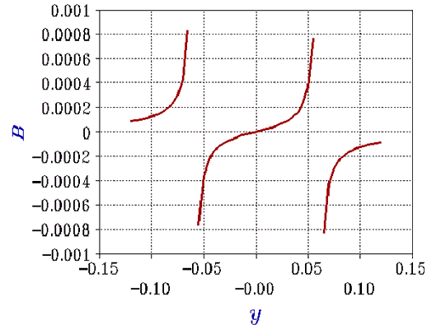

26 · Find B at points on the y axis as in Problem 24 when the current in the wire at y = –6 cm is in the negative x direction and the current in the wire at y = +6 cm is in the positive x direction.
Use the results of Problem 24 but reverse the direction of B₊.
(a) B = –1.78×10^{–4} T k; (b) B₊ = B– = –6.667×10^{–5} T k; B = –1.33×10^{–4} T k; (c) B = –1.78×10^{–4} T k;
(d) B = 1.07×10^{–4} T k

27 · Sketch B_{z} versus y for points on the y axis when the directions of the currents are
opposite to those in Problem 26.

The field B_{x} versus y is shown in the adjacent figure. Here B_{x} is in units of 10^{–4} T and y is in centimeters. The field is singular at y = ±6 cm. | 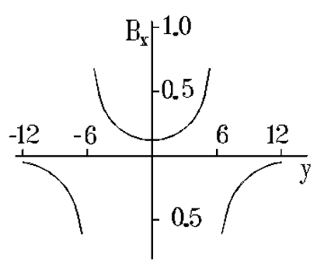

28 · Find B on the z axis at z = +8 cm if (a) the currents are parallel, as in Problem 24 and (b) the currents are antiparallel, as in Problem 26.
- 1. Show the fields in the y-z plane for currents  in the positive x direction. Note that B_{z} = 0,  and that the y components add. R = 10 cm. | 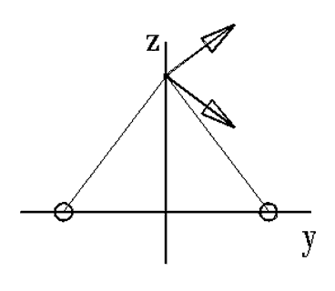
2. Evaluate B_{y} from each current and add. B = 2(4×10^{–5} ×0.8) T j = 6.4×10^{–5} T j

- 1. Show the fields in the y-z plane with the  currents oppositely directed, i.e., the current at  y = 6 cm reversed with respect to part (a).  Note that now B_{y} = 0 and the z components are  negative and add. R = 10 cm. | 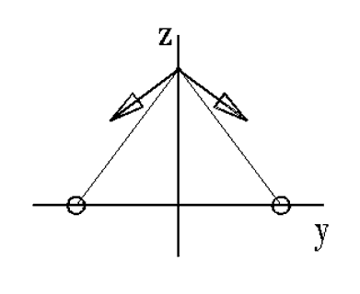
2. Evaluate B_{z} for each current and add B = –2(4×10^{–5} ×0.6) T k = –4.8×10^{–5} T k

29* · Find the magnitude of the force per unit length exerted by one wire on the other.

Use Equs. 29-12 and 28-5; F/ = μ₀I²/2πR
F/ = 6.67×10^{–4} N/m

30 · Two long, straight, parallel wires 8.6 cm apart carry currents of equal magnitude I. They repel each other with a force per unit length of 3.6 nN/m. (a) Are the currents parallel or antiparallel? (b) Find I.
(a) Since the currents repel they are antiparallel.
(b) Use Equ. 29-13 with I₁ = I₂ = I; solve for I | I = [(F/)R/2×10^{–7}]^{1/2} = 0.0393 A

31 ·· The current in the wire of Figure 29-40 is 8.0 A. Find B at point P due to each wire segment and sum to find the resultant B.
We note that the current segments a-b and e-f do not contribute to the magnetic field at point P. The current in the segments b-c, c-d, and d-e result in a magnetic field at P that points into the plane of the paper. Note that the angles bPc and ePd are 45°. | 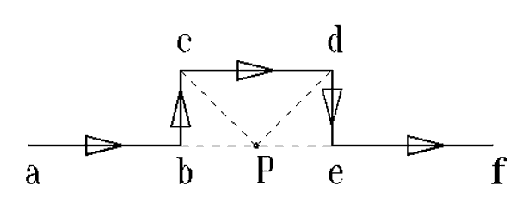

Use Equ. 29-11 to find B due to each segment. Add the three contributions to find B at P.
B_{bc} = (10^{–7} ×8.0/0.01)(sin 45°) T = 5.657×10^{–5} T = B_{de}
B_{cd} = 2B_{bc}; B = 4B_{bc} = 2.26×10^{–4} T

32 ·· A wire of length 16 cm is suspended by flexible leads above a long, straight wire. Equal but opposite currents are established in the wires such that the 16-cm wire floats 1.5 mm above the long wire with no tension in its suspension leads. If the mass of the 16-cm wire is 14 g, what is the current?
Since tension = 0, F_{B} = mg = 2×10^{–7}I ²L/R

33* ·· Three long, parallel, straight wires pass through the corners of an equilateral triangle of sides 10 cm as shown in Figure 29-41, where a dot means that the current is out of the paper and a cross means that it is into the paper. If each current is 15.0 A, find (a) the force per unit length on the upper wire, and (b) the magnetic field B at the upper wire due to the two lower wires.
- The forces on the upper wire are away from  B = –2(4×10^{–5} ×0.6) T k = –4.8×10^{–5} T k and directed along the line to the lower wires  (b) By symmetry, B_{y} = 0; use F_{y} = B_{x}I | F_{i}/ = μ₀I²/2πR = 4.5×10^{–4} N/m;  F_{y}/ = 2(F_{i} /) sin 60° = 7.79×10^{–4} N/m  B = B_{x} i; B_{x} = F_{y}/I = 5.20×10^{–5} T

34 ·· Work Problem 33 with the current in the lower right corner of Figure 29-41 reversed.
- The forces on the upper wire are away from the lower left hand wire and toward the lower right-  hand wire. The forces are as in Problem 33.  (b) By symmetry, B_{y} = 0; use F_{x} = B_{z}I | F_{i}/ = μ₀I²/2πR = 4.5×10^{–4} N/m;  F_{x}/ = 2(F_{i} /) cos 60º = 4.5×10^{–4} N/m  B = –B_{x} k; B_{z} = F_{x}/I = 3.0×10^{–5} T

35 ·· An infinitely long, insulated wire lies along the x axis and carries current I in the positive x direction. A second infinitely long, insulated wire lies along the y axis and carries current I in the positive y direction. Where in the xy plane is the resultant magnetic field zero?
B = 0 along a line that makes an angle of 45° with the x axis.

36 ·· An infinitely long wire lies along the z axis and carries a current of 20 A in the positive z direction. A second infinitely long wire is parallel to the z axis at x = 10 cm. (a) Find the current in the second wire if the magnetic field at x = 2 cm is zero. (b) What is the magnetic field at x = 5 cm?
(a) 1. Use the right-hand rule to find the direction of the current at x = 10 cm so that B = 0 at x = 2 cm.  2. Use Equ. 29-12 to write B at x = 2 cm  3. Solve for I₂  (b) Use Equ. 29-12 to find B at x = 5 cm | I₂ is in the positive z direction  B = 2×10^{–7}(20/0.02 – I₂/0.08) = 0  I₂ = 80 A  B = 2×10^{–7}(20/0.05 – 80/0.05) T j = 0.24 mT j

37* ·· Three very long, parallel wires are at the corners of a square, as shown in Figure 29-42. They each carry a current of magnitude I. Find the magnetic field B at the unoccupied corner of the square when (a) all the currents are into the paper, (b) I₁ and I₃ are in and I₂ is out, and (c) I₁ and I₂ are in and I₃ is out.

(a) Use Equ. 29-12; let C = μ₀I/2πL  B = B₁ + B₂ + B₃ | B₁ = –C j, B₂ = (C/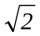)(i – j)/, B₃ = C i  B = (3C/2)(i – j) = (3μ₀I/4πL)(i – j) | 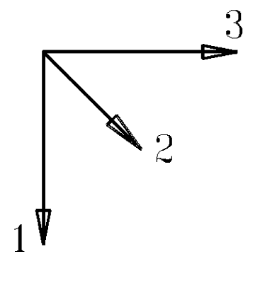
(b) Proceed as in part (a); note that B₂ is reversed  B = B₁ + B₂ + B₃ | B₁ = –C j, B₂ = (C/2)(–i + j), B₃ = C i  B = (μ₀I/4πL)(i – j) | 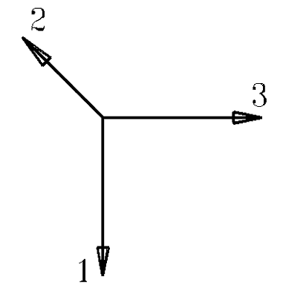
(c) Proceed as in part (a); note that B₃ is reversed  B = B₁ + B₂ + B₃ | B₁ = –C j, B₂ = (C/2)(i – j), B₃ = –C i  B = (μ₀I/4πL)(–i –3j) | 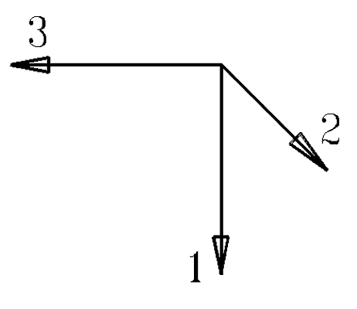

38 ·· Four long, straight, parallel wires each carry current I. In a plane perpendicular to the wires, the wires are at the corners of a square of side a. Find the force per unit length on one of the wires if (a) all the currents are in the same direction, and (b) the currents in the wires at adjacent corners are oppositely directed.

(a) Use the result of Problem 37a and Equ. 28-2 for the force on the upper right-hand wire. (Let L = a)
(b) Use the result of Problem 37b and Equ. 28-2 for the force on the upper right-hand wire.
F/L = (3μ₀I ²/4πa)(i + j);
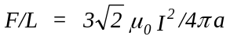
F/L = (μ₀I ²/4πa)(i + j);
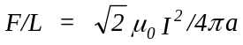

39 ·· An infinitely long, nonconducting cylinder of radius R lies along the z axis. Five long, conducting wires are parallel to the cylinder and spaced equally on the upper half of its surface. Each wire carries a current I in the positive z direction. Find the magnetic field on the z axis.

The configuration is shown in the adjacent figure. Here the z axis points out of the plane of the paper, the x axis points to the right, the y axis points up. It is evident that the y component of B = 0. The magnitude of B due to each current at z = 0 is μ₀I/2πR. Adding the x components one obtains B = 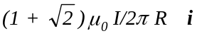 . | 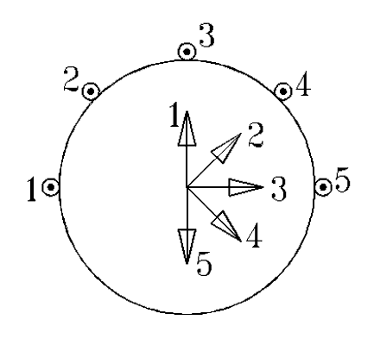

40 · A solenoid with length 30 cm, radius 1.2 cm, and 300 turns carries a current of 2.6 A. Find B on the axis of the solenoid (a) at the center, (b) inside the solenoid at a point 10 cm from one end, and (c) at one end.

(a) Use Equ. 29-8; a = b =0. 15 m, R =0.012 m,
n = 1000, I = 2.6 A
(b) a = 0.10 m, b = 0.20 m
(c) a = 0, b = 0.30 m
B = 3.26×10^{–3} T

B = 3.25×10^{–3} T
B = 1.63×10^{–3} T; note that B_{c} = B_{a}/2

41* · A solenoid 2.7 m long has a radius of 0.85 cm and 600 turns. It carries a current I of 2.5 A. What is the approximate magnetic field B on the axis of the solenoid?
Use Equ. 29-9 | B = (4π×10^{–7} ×600×2.5/2.7) T = 0.698 mT

42 ··· A solenoid has n turns per unit length and radius R and carries a current I. Its axis is along the x axis with one end at x = 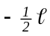 and the other end at x = 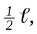 where l is the total length of the solenoid. Show that the magnetic field B at a point on the axis outside the solenoid is given by
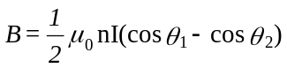
where
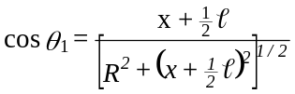
and
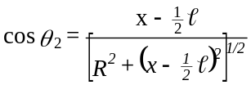

The solenoid, extending from x = –/2 to x = /2 is shown in the figure. To find the field at the point x outside the solenoid we shall determine the field at x due to a infinitesimal segment of the solenoid of width dx′ at x′, and then integrate from x = –l/2 to l/2. The segment may be considered as a coil ndx' carrying a current I. The field dB is then given by Equ. 29-5. Integrating dB we have | 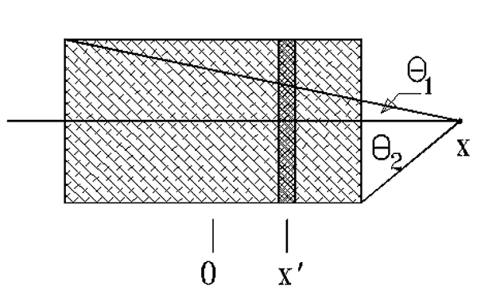

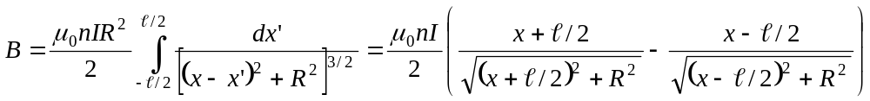
The two terms in the parentheses can be rewritten in tems of the angles θ ₁ and θ ₂ between the axis of the solenoid and the lines to the two ends of the solenoid to obtain Equ. 29-35.

43 ··· In Problem 42, a formula for the magnetic field along the axis of a solenoid is given. For x >> l and l > R, the angles θ₁ and θ₂ in Equation 29-35 are very small, so the small-angle approximation cos θ ≈ 1 – θ ²/2 is valid. (a) Draw a diagram and show that
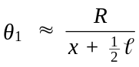 and 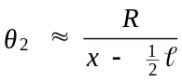
(b) Show that the magnetic field at a point far from either end of the solenoid can be written
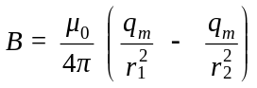

where r₁ = x –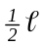is the distance to the near end of the solenoid, r₂ = x + is the distance to the far end, and q_{m} = nIπR² = μ/, where μ = NIπR² is the magnetic moment of the solenoid.
(a) The two angles θ ₁ amd θ ₂ are shown in the figure of the preceding problem. Note that tan θ ₁ = R/(x + /2) and tan θ ₂ = R/(x – /2). For the conditions stated, both angles are small. Consequently, θ ₁ ≈ R/(x + /2) and
θ ₂ ≈ R/(x – /2).
(b) Using the small angle approximation, cos θ ₁ – cos θ ₂ = (R²/2)[1/(x – /2)² – 1/(x + /2)²]. With q_{m} = nIπR² and x – /2 = r₁ and x + /2 = r₂ the field B is given by Equ. 29-37.

44 ··· In this problem, you will derive Equation 29-37 by another method. Consider a long, tightly wound solenoid of length and radius R << lying along the axis with its center at the origin. It has N turns and carries a current I. Consider an element of the solenoid of length dx. (a) What is the magnetic moment of this element? (b) Show that the magnetic field dB due to this element at a point on the x axis x₀ far from the element is given by
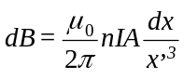
where A = πR² and x′ = x₀ – x is the distance from the element to the field point. (c) Integrate this expression from x = to x = 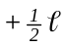 to obtain Equation 29-37.
(a) The magnetic dipole moment of a coil of N turns and area A that carries a current I is given by μ = NIA. Since n = N/, the quantity q_{m} = nIA = nIπR² is the magnetic dipole moment per unit length. Hence, q_{m} dx = nIAdx is the magnetic dipole moment of an infinitesimal width dx.
(b) The field dB_{x} due to this dipole at x′ is given by Equ. 29-6; i.e., 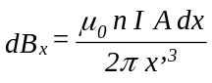.
(c) The field B_{x} at x₀ is obtained by integrating dB_{x} from –/2 to /2 where x′ = x₀ – x. Thus,
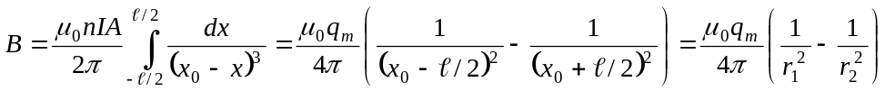0, which is identical to
the result obtained in the preceding problem.

45* · Ampère's law is valid
(a) when there is a high degree of symmetry.
(b) when there is no symmetry.
(c) when the current is constant.
(d) when the magnetic field is constant.
(e) in all of these situations if the current is continuous.
(e)

46 · A long, straight, thin-walled, cylindrical shell of radius R carries a current I. Find B inside and outside the cylinder.
We use Equ. 29-15 and integrate around a circle centered on the axis of the cylinder. By symmetry, the field is the same everywhere on this circle. For r < R the enclosed current is zero. Consequently, B = 0 inside the cylinder.
For r > R, I_{C} = I and the integral is 2π rB. Thus, B = μ₀I/2π r.

47 · In Figure 29-43, one current is 8 A into the paper, the other current is 8 A out of the paper, and each curve is a circular path. (a) Find 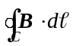 for each path indicated. (b) Which path, if any, can be used to find B at some point due to these currents?
(a) For path C₁, the line integral is μ₀(8 A); for path C₃, the line integral is –μ₀(8 A) since the field is opposite to the direction of integration; for path C₂, the line integral is zero since the enclosed current is zero.
(b) None of the path integrals can be used to find B at some point because there the current configuration does not have cylindrical symmetry.

48 · A very long, coaxial cable consists of an inner wire and a concentric outer cylindrical conducting shell of radius R. At one end, the wire is connected to the shell. At the other end, the wire and shell are connected to opposite terminals of a battery, so there is a current down the wire and back up the shell. Assume that the cable is straight. Find B (a) at points between the wire and the shell far from the ends, and (b) outside the cable.
(a) From Equ. 29-15, B = μ₀I/2π r for r < R. (b) The enclosed current is zero, consequently B = 0 for r > R.

49* ·· A wire of radius 0.5 cm carries a current of 100 A that is uniformly distributed over its cross-sectional area. Find B (a) 0.1 cm from the center of the wire, (b) at the surface of the wire, and (c) at a point outside the wire 0.2 cm from the surface of the wire. (d) Sketch a graph of B versus the distance from the center of the wire.
We shall consider the general case first. Consider a wire of radius a carrying a current I of uniform current density.

1. For r < a, find I within area of radius r < a
2. Use Equ. 29-15
3. For r ≥ a, use Equ. 29-12
(a) Use the result for r < a; I = 100 A, a = 0.5 cm
(b) Use the result for r ≥ a
(c) Use the result for r > a
(d) The graph of B versus r is shown
I(r) = Ir²/a²
2πrB = μ₀Ir²/a²; B = μ₀Ir/2πa²
B = μ₀I/2πr
B = 8×10^{–4} T
B = 4×10^{–3} T
B = 2.86×10^{–3} T
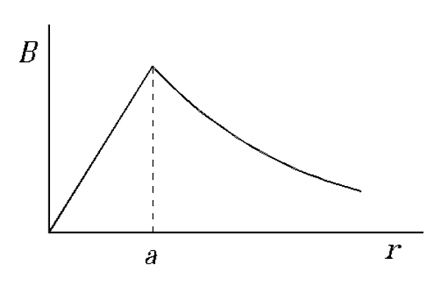

50 ·· Show that a uniform magnetic field with no fringing field, such as that shown in Figure 29-44, is impossible because it violates Ampère's law. Do this by applying Ampère's law to the rectangular curve shown by the dashed lines.
The contour integral consists of four portions, two horizontal portions for which B.d = 0, and two vertical portions. The portion within the magnetic field gives a nonvanishing contribution, whereas the portion outside the field gives no contribution to the contour integral. Hence the contour integral has a finite value. However, it encloses no current; thus, it appears that Ampère’s law is violated. What this demonstrates is that there must be a fringing field so that the contour integral does vanish.

51 ·· A coaxial cable consists of a solid inner cylindrical conductor of radius 1.00 mm and an outer cylindrical shell conductor of inner radius 2.00 mm and outer radius 3.00 mm. There is a current of 18 A down the inner wire and an equal return current in the outer conductor. The currents are uniform over the cross section of each conductor. Find the numerical value of for a closed circular path (centered on the axis of the cable and in a plane perpendicular to the axis) which has a radius r for (a) r = 1.50 mm, (b) r = 2.50 mm, and (c) r = 3.50 mm.
(a) Use Equ. 29-15; for r = 1.5 mm, I_{C} = 18 A  (b) 1. Find the current density in the outer conductor  2. Find I_{C} for r = 2.5 mm and path integral  (c) For r > 3.0 mm, I_{C} = 0 | 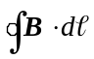 = 2.26×10^{–5} T.m  J = 18/[π(9.0 – 4.0)] A/mm²  I_{C} = 18 – Jπ[(6.25 – 4.0) mm²] = 9.9 A;  = 1.24×10^{–5} T.m  = 0

52 ·· An infinitely long, thick, cylindrical shell of inner radius a and outer radius b carries a current I uniformly distributed across a cross section of the shell. Find the magnetic field for (a) r < a, (b) a < r < b, and (c) r > b.
(a) For r < a, I_{C} = 0; consequently, B = 0 (see Problem 46).
(b) The current density is I/[π(b² – a²)]. The enclosed current within a radius a < r < b is then given by
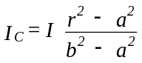 and the magnetic field is given by 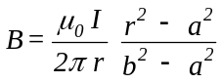
(c) For r > b, I_{C} = I and 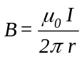

53* ·· Figure 29-45 shows a solenoid carrying a current I with n turns per unit length. Apply Ampère’s law to the rectangular curve shown to derive an expresion for B assuming that it is uniform inside the solenoid and zero outside it.
The number of turns enclosed within the rectangular area is na. Note that outside the solenoid B = 0 and within the solenoid on the paths along b, = 0. Using Ampère’s law, we have aB = μ₀naI and B = μ₀nI.

54 ·· A tightly wound toroid of inner radius 1 cm and outer radius 2 cm has 1000 turns of wire and carries a current of 1.5 A. (a) What is the magnetic field at a distance of 1.1 cm from the center? (b) What is the field 1.5 cm from the center?
(a), (b) Use Equ. 29-17 | (a) B = 0.0273 T; (b) B = 0.0200 T

55 ·· The xz plane contains an infinite sheet of current in the positive z direction. The current per unit length (along the x direction) is λ. Figure 29-46a shows a point P above the sheet (y > 0) and two portions of the current sheet labeled I₁ and I₂. (a) What is the direction of the magnetic field B at P due to the two portions of the current shown? (b) What is the direction of the magnetic field B at P due to the entire sheet? (c) What is the direction of B at a point below the sheet (y < 0)? (d) Apply Ampère's law to the rectangular curve shown in Figure 29-46b to show that the magnetic field at any point above the sheet is given by B = μ₀λi.
(a) At P the magnetic field points to the right since the vertical components cancel. Since k is into the sheet of the paper, i points to the left; i.e., B is in the –i direction
(b) Since the sheet is infinite, the same argument as in (a) applies; B at P is in the –i direction.
(c) At a point below the sheet B points to the left, i.e., in the i direction.
(d) The enclosed current is λw. The contour integral is then 2wB and therefore B = –(μ₀λ/2) i at any point above the sheet.

56 · True or false:
(a) Diamagnetism is the result of induced magnetic dipole moments.
(b) Paramagnetism is the result of the partial alignment of permanent magnetic dipole moments.
(a) True (b) True

57* · If the magnetic susceptibility is positive,
(a) paramagnetic effects or ferromagnetic effects must be greater than diamagnetic effects.
(b) diamagnetic effects must be greater than paramagnetic effects.
(c) diamagnetic effects must be greater than ferromagnetic effects.
(d) ferromagnetic effects must be greater than paramagnetic effects.
(e) paramagnetic effects must be greater than ferromagnetic effects.
(a)

58 · A tightly wound solenoid 20 cm long has 400 turns and carries a current of 4 A such that its axial field is in the z direction. Neglecting end effects, find B and B_{app} at the center when (a) there is no core in the solenoid, and (b) there is an iron core with a magnetization M = 1.2×10⁶ A/m.
(a), (b) Use Equs. 29-9 and 29-21 | (a) B_{app} = B = 10.1 mT  (b) B_{app} = 10.1 mT; B = 1.52 T

59 · Which of the four gases listed in Table 29-1 are diamagnetic and which are paramagnetic?
H₂, CO₂, and N₂ are diamagnetic (χ_{m} < 0); O₂ is paramagnetic (χ_{m} > 0).

60 · If the solenoid of Problem 58 has an aluminum core, find B_{app}, M, and B at the center, neglecting end effects.
Use Equs. 29-9, 29-22, and 29-24; χ_{m} = 2.3×10^{–5} | B_{app} = 10.1 mT; M = 0.183 A/m; B = 10.1 mT

61* · Repeat Problem 60 for a tungsten core.
1. Find B_{app} in the solenoid; use Equ. 29-9  2. M = χ_{m}B_{app}/μ₀ = χ_{m}nI; χ_{m} = 6.8×10^{–5} (see Table 29-1)  3. B = B_{app}(1 + χ_{m}) | B_{app} = 10.053 mT  M = 0.544 A/m  B = 10.054 mT

62 · A long solenoid is wound around a tungsten core and carries a current. (a) If the core is removed while the current is held constant, does the magnetic field inside the solenoid decrease or increase? (b) By what percentage?
(a) For W, χ_{m} > 0. Therefore B will diminish if the tungsten core is removed.
(b) The percentage change is 100χ_{m} = 6.8×10^{–3} percent.

63 · When a sample of liquid is inserted into a solenoid carrying a constant current, the magnetic field inside the solenoid decreases by 0.004%. What is the magnetic susceptibility of the liquid?
(a) Percent change in B = 100χ_{m} (see Problem 62) | χ_{m} = –4×10^{–3}/100 = –4×10^{–5}

64 · A long solenoid carrying a current of 10 A has 50 turns/cm. What is the magnetic field in the interior of the solenoid when the interior is (a) a vacuum, (b) filled with aluminum, and (c) filled with silver?
(a), (b), (c) Use Equs. 29-9 and 29-24 | - B = B_{app} = 62.8 mT; (b) 1 + χ_{m} = 1+ 2.3×10^{–5} ≈ 1.00, so  B = 62.8 mT; (c) 1 + χ_{m} = 1 – 2.6×10^{–5}, B ≈ 62.8 mT

65* ·· An engineer intends to fill a solenoid with a mixture of oxygen and nitrogen at room temperature and 1 atmosphere pressure such that K_{m} is exactly 1. Assume that the magnetic dipole moments of the gas molecules are all aligned and that the susceptibility of a gas is proportional to the number density of its molecules. What should the ratio of the number densities of oxygen to nitrogen molecules be so that K_{m} = 1?
If K_{m} = 1, χ_{m} = 0; so n_{O}χ_{mO} + n_{N}χ_{mN} = 0 | n_{O}/n_{N} = –χ_{mN}/χ_{mO} = 0.00239

66 ·· A cylinder of magnetic material is placed in a long solenoid of n turns per unit length and current I. Table 29-3 gives the magnetic field B versus nI. Use these values to plot B versus B_{app} and K_{m} versus nI.
The applied field B_{app} for a long solenoid is given by
Equ. 29-9, i.e., B_{app} = μ₀nI. The abscissa for the first graph
is obtained by multiplying nI by μ₀.

The graph is shown on the right. B initially rises rapidly, and then becomes nearly flat. This is characteristic of a ferromagnetic material. | 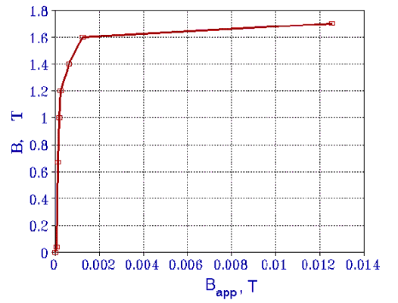

The plot of K_{m} versus nI is shown using a logarithmic scale for the abscissa. Note that K_{m} becomes quite large for small values of nI but then diminishes. A more revealing graph would be to plot ΔB/Δ(nI), which would be quite large for small values of nI and then drop to nearly zero at nI = 10,000 A/m, corresponding to saturation of the magnetization. | 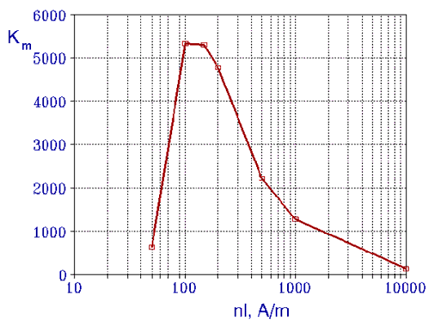

67 ·· A small magnetic sample is in the form of a disk having a radius of 1.4 cm, a thickness of 0.3 cm, and a uniform magnetization along its axis throughout its volume. The magnetic moment of the sample is 1.5×10^{–2} A⋅m². (a) What is the magnetization M of the sample? (b) If this magnetization is due to the alignment of N electrons each with a magnetic moment of 1 μ_{B}, what is N? (c) If the magnetization is along the axis of the disk, what is the magnitude of the amperian surface current?

(a) M = μ/V (see Equ. 29-18)
(b) μ = Nμ_{B}
(c) μ = AI = M/V; I = M/t, where t = thickness of disk
M = [1.5×10^{–2}/(π×0.014² ×0.003)] A/m = 8.12×10³ A/m
N = 1.5×10^{–2}/9.27×10^{–24} = 1.62×10²¹
I = 8.12×10^{–3}/0.003 = 24.4 A

68 ·· The magnetic moment of the earth is about 9×10²² A⋅m². (a) If the magnetization of the earth's core were 1.5×10⁹ A/m, what is the core volume? (b) What is the radius of such a core if it were spherical and centered with the earth?
(a) V = μ/M  (b) V = (4π/3)r³ | V = (9×10²²/1.5×10⁹) m³ = 6×10¹³ m³  r = 2.43×10⁴ m

69* ·· Nickel has a density of 8.7 g/cm³ and molecular mass of 58.7 g/mol. Its saturation magnetization is given by ₀M_{s} = 0.61 T. Calculate the magnetic moment of a nickel atom in Bohr magnetons.
μ = M_{s}/(μ₀N_{A}ρ/M); number of μ_{B} = μ/μ_{B} | μ = 0.587 μ_{B}

70 ·· Repeat Problem 69 for cobalt, which has a density of 8.9 g/cm³, a molecular mass of 58.9 g/mol, and a saturation magnetization given by ₀M_{s} = 1.79 T.
μ = M_{s}/(μ₀N_{A}ρ/M); number of μ_{B} = μ/μ_{B} | μ = 1.69 μ_{B}

71 · Show that Curie's law predicts that the magnetic susceptibility of a paramagnetic substance is χ_{m} = μμ₀M_{s}/3kT.
If we set Equ. 29-22 equal to Equ. 29-33 and solve for χ_{m} we obtain χ_{m} = μμ₀M_{s}/3kT.

72 ·· In a simple model of paramagnetism, we can consider that some fraction f of the molecules have their magnetic moments aligned with the external magnetic field and that the rest of the molecules are randomly oriented and so do not contribute to the magnetic field. (a) Use this model and Curie's law to show that at temperature T and external magnetic field B the fraction of aligned molecules is f = μB/3kT. (b) Calculate this fraction for T = 300 K, B = 1 T, assuming μ to be 1 Bohr magneton.
(a) As stated, M = fM_{s} = μB_{app}M_{s}/3kT. Since B given in the problem is the external magnetic field, B = B_{app}, and solving for f one obtains f = μB/3kT.
(b) With μ = μ_{B} = 9.27×10^{–24} J/T and B = 1 T, f = 7.46×10^{–4} Hz

73* ·· Assume that the magnetic moment of an aluminum atom is 1 Bohr magneton. The density of aluminum is 2.7 g/cm³, and its molecular mass is 27 g/mol. (a) Calculate M_{s} and μ₀M_{s} for aluminum. (b) Use the results of Problem 71 to calculate χ_{m} at T = 300 K. (c) Explain why the result for part (b) is larger than the value listed in Table 29-1.
(a) M_{s} = (N_{A}ρ/M)μ_{B};  B_{s} = μ₀M_{s}  (b) χ_{m} = μ_{B}μ₀M_{s}/3kT = μ_{B}B_{s}/3kT | M_{s} = 6.02×10²⁸ ×9.27×10^{–24} A/m = 5.58×10⁵ A/m  B_{s} = 0.701 T  χ_{m} = 9.27×10^{–24} ×0.701/(3×1.38×10^{–23} ×300) = 5.23×10^{–4}
(c) In arriving at χ_{m} in part (b) we have neglected any diamagnetic effects.

74 ·· A toroid with N turns carrying a current I has mean radius R and cross-sectional radius r, where r << R (Figure 29-47). When the toroid is filled with material, it is called a Rowland ring. Find B_{app} and B in such a ring, assuming a magnetization M everywhere parallel to B_{app}.
For a toroid, B_{app} = μ₀NI/2πa for R – r < a < R + r. From Equ. 29-21 one can write B = μ₀NI/2πa + μ₀M.

75 ·· A toroid is filled with liquid oxygen that has a susceptibility of 4×10⁻³. The toroid has 2000 turns and carries a current of 15 A. Its mean radius is 20 cm, and the radius of its cross section is 0.8 cm. (a) What is the magnetization M? (b) What is the magnetic field B? (c) What is the percentage increase in B produced by the liquid oxygen?
(a) M = χ_{m}B_{app}/μ₀; B_{app} = μ₀NI/2πr_{mean}  (b) B = B_{app}(1 + χ_{m})  (c) ΔB/B = χ_{m} | M = (4×10^{–3} ×2000×15/0.4π) A/m = 95.5 A/m  B = 0.0301 T  percent increase = 0.4%

76 ·· A toroid has an average radius of 14 cm and a cross-sectional area of 3 cm². It is wound with fine wire, 60 turns/cm measured along its mean circumference, and the wire carries a current of 4 A. The core is filled with a paramagnetic material of magnetic susceptibility 2.9×10^{–4}. (a) What is the magnitude of the magnetic field within the substance? (b) What is the magnitude of the magnetization? (c) What would the magnitude of the magnetic field be if there were no paramagnetic core present?
(a) B_{app} = μ₀NI/2πR_{av} = μ₀nI; B = B_{app}(1 + χ_{m})  (b) M = χ_{m}B_{app}/μ₀  (c) B = B_{app} | B = (1.00029)(4π×10^{–7} ×6000×4) T = 0.0302 T  M = 6.96 A/m  B = 0.0302 T

77* · For annealed iron, the relative permeability K_{m} has its maximum value of about 5500 at B_{app} = 1.5710^{–4} T. Find M and B when K_{m} is maximum.
B = K_{m}B_{app}; M = (K_{m} – 1)B_{app}/μ₀ ≅ K_{m}B_{app}/μ₀ | B = 0.864 T; M = 6.87×10⁵ A/m

78 ·· The saturation magnetization for annealed iron occurs when B_{app} = 0.201 T. Find the permeability μ and the relative permeability K_{m} of annealed iron at saturation. (See Table 29-2.)
Use Equ. 29-22; μ = (1 + χ_{m})μ₀; K_{m} = 1 + χ_{m} | χ_{m} = 2.16/0.201 = 10.75; K_{m} = 11.75; μ = 1.48×10^{–5}

79 ·· The coercive force is defined to be the applied magnetic field needed to bring B back to zero along the hysteresis curve (point c in Figure 29-35). For a certain permanent bar magnet, the coercive force B_{app} = 5.53×10^{–2} T. The bar magnet is to be demagnetized by placing it inside a 15-cm-long solenoid with 600 turns. What minimum current is needed in the solenoid to demagnetize the magnet?
Use Equ. 29-9 with B = B_{app} | n = 600/0.15 = 4000 m^{–1}; I = 11.0 A

80 ·· A long solenoid with 50 turns/cm carries a current of 2 A. The solenoid is filled with iron, and B is measured to be 1.72 T. (a) Neglecting end effects, what is B_{app}? (b) What is M? (c) What is the relative permeability K_{m}?
(a) Use Equ. 29-9  (b) Use Equ. 29-21  (c) Use Equ. 29-23 | B_{app} = 0.0126 T  M = 1.707/μ₀ = 1.36×10⁶ A/m  K_{m} = 1.72/0.0126 = 136.5

81* ·· When the current in Problem 80 is 0.2 A, the magnetic field is measured to be 1.58 T. (a) Neglecting end effects, what is B_{app}? (b) What is M? (c) What is the relative permeability K_{m}?
(a) Find B_{app} = μ₀nI  (b) M = (B – B_{app})/μ₀  (c) K_{m} = B/B_{app} | B_{app} = 1.26×10^{–3} T  M = 1.26×10⁶ A/m  K_{m} = 1.25×10³

82 ·· A long, iron-core solenoid with 2000 turns/m carries a current of 20 mA. At this current, the relative permeability of the iron core is 1200. (a) What is the magnetic field within the solenoid? (b) With the iron core removed, what current will produce the same field within the solenoid?
(a) Use Equs. 29-9 and 29-23  (b) I₀ = K_{m}I | B = K_{m}μ₀nI = 0.0603 T  I = 24 A

83 ·· Two long, straight wires 4.0 cm apart are embedded in a uniform insulator having relative permeability of K_{m} = 120. The wires carry 40 A in opposite directions. (a) What is the magnetic field at the midpoint of the plane of the wires? (b) What is the force per unit length on the wires?
(a) B = K_{m}B_{app}; B_{app} = 2(μ₀I/2πr); r = 2.0 cm  (b) F/L = BI, where B = 0.024 T | B = 0.096 T  F/L = 0.96 N/m

84 ·· The toroid of Problem 75 has its core filled with iron. When the current is 10 A, the magnetic field in the toroid is 1.8 T. (a) What is the magnetization M? (b) Find the values for K_{m}, μ, and χ_{m} for the iron sample.
(a) 1. Use Equ. 29-17 to find B_{app}  2. From Equ. 29-21 M = (B – B_{app})/μ₀  (b) K_{m} = B/B_{app}; μ = K_{m} μ₀;χ_{m} = K_{m} – 1 | B_{app} = 0.0200 T  M = 1.42×10⁶ A/m  K_{m} = 90; μ = 1.13×10^{–4} T.m/A; χ_{m} = 89

85* ·· Find the magnetic field in the toroid of Problem 76 if the current in the wire is 0.2 A and soft iron, having a relative permeability of 500, is substituted for the paramagnetic core?
1. Find B_{app} using Equ. 29-9  2. B = K_{m}B_{app} | B_{app} = 1.508 mT  B = 0.754 T

86 ·· A long, straight wire with a radius of 1.0 mm is coated with an insulating ferromagnetic material that has a thickness of 3.0 mm and a relative magnetic permeability of K_{m} = 400. The coated wire is in air and the wire itself is nonmagnetic. The wire carries a current of 40 A. (a) Find the magnetic field inside the wire as a function of radius r. (b) Find the magnetic field inside the ferromagnetic material as a function of radius r. (c) Find the magnetic field outside the ferromagnetic material as a function of r. (d) What must the magnitudes and directions of the amperian currents be on the surfaces of the ferromagnetic material to account for the magnetic fields observed?
(a) Use Equ. 29-15 with I_{C} = Ir²/R²; R = 1.0 mm  (b) B_{app} = μ₀I/2πr (Equ. 29-12); B = K_{m} B_{app}  (c) Use Equ. 29-12 | B = μ₀Ir/2πR² = 8r T (r in m)  B = (3.2×10^{–3})/r T for 1×10^{–3} m < r < 4×10^{–3} m  B = (8×10^{–6})/r T for r > 4×10^{–3} m

(d) Note that the field in the ferromagnetic region is that which would be produced in a nonmagnetic region by a current of 400I = 1600 A. The amperian current on the inside of the surface of the ferromagnetic material must therefore be (1600 – 40) A = 1560 A in the direction of I. On the ouside surface there must then be an amperian current of 1560 A in the opposite direction.

87 · True or false:
(a) The magnetic field due to a current element is parallel to the current element.
(b) The magnetic field due to a current element varies inversely with the square of the distance from the element.
(c) The magnetic field due to a long wire varies inversely with the square of the distance from the wire.
(d) Ampère's law is valid only if there is a high degree of symmetry.
(e) Ampère's law is valid only for continuous currents.
(a) False (b) True (c) False (d) False (e) True

88 · Can a particle have angular momentum and not have a magnetic moment?
Yes, if the charge density is zero.

89* · Can a particle have a magnetic moment and not have angular momentum?
No

90 · A circular loop of wire carries a current I. Is there angular momentum associated with the magnetic moment of the loop? If so, why is it not noticed?
Yes, there is angular momentum associated with the magnetic moment. The magnitude of L is extremely small (see Problem 110), but very sensitive experiments have demonstrated its presence (Einstein-de Haas effect).

91 · A hollow tube carries a current. Inside the tube, B = 0. Why is this the case, since B is strong inside a solenoid?
From Ampère’s law, the enclosed current within the tube is zero, and from the cylindrical symmetry it follows that B = 0 within the tube.

92 · When a current is passed through the wire in Figure 29-48, will it tend to bunch up or form a circle?
The wire will tend to form a circle.

93* · Find the magnetic field at point P in Figure 29-49.
B only due to semicircle; B = μ₀I/4R | B = 2.36×10^{–5} T

94 · In Figure 29-50, find the magnetic field at point P, which is at the common center of the two semicircular arcs.
At the center of a semicircle of current I B = μ₀I/4R (see Equ. 29-4). The fields due to the two semicircles are oppositely directed, so at point P B = (μ₀I/4)(1/R₁ – 1/R₂), and B points out of the plane of the paper.

95 ·· A wire of length l is wound into a circular coil of N loops and carries a current I. Show that the magnetic field at the center of the coil is given by B = μ₀πN ²I/.
At the center of a coil of N turns and radius R, B = μ₀NI/2R. The number of turns and the radius are related to the length of the wire by 2πRN = . Replacing R by /2πN one obtains B = μ₀πIN ²/.

96 ·· A very long wire carrying a current I is bent into the shape shown in Figure 29-51. Find the magnetic field at point P.
Note that the three portions all give rise to a magnetic field at P the points out of the plane of the paper. To find B, use Equ. 29-11. For the long portions, θ ₁ = 90° and θ ₂ = 45°; for the portion of length 2a, θ ₁ = θ ₂ = 45°. The distance R is a. Thus Equ. 29-11 gives B = (μ₀I/2πa)(1 + ).

97* ·· A loop of wire of length carries a current I. Compare the magnetic fields at the center of the loop when it is (a) a circle, (b) a square, and (c) an equilateral triangle. Which field is largest?
(a) Express B in terms of  (b) Use Equ. 29-11; R = /8; θ₁ = θ₂ = 45°  (c) Use Equ. 29-11; R = (/3)/(2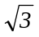); θ₁ = θ₂ = 60°  The largest B is for the equilateral triangle | B = μ₀I/2R = πμ₀I/ = 3.14μ₀I/  B = [(μ₀/4π)8I/](2 sin θ) = 8μ₀I/π = 3.60μ₀I/  B = 27μ₀I/2π = 4.30μ₀I/

98 ·· A power cable carrying 50.0 A is 2.0 m below the earth's surface, but its direction and precise position are unknown. Show how you could locate the cable using a compass. Assume that you are at the equator, where the earth's magnetic field is 0.7 G north.
The field due to the cable is B_{cable} = 2×10^{–7} ×50/2 = 5×10^{–6} T = 0.05 G. This is only about 7% of the earth’s field but should be detectable with a good compass. 1. If the cable runs east-west, its magnetic field is in the north-south direction and thus either adds to or subtracts from the earth’s field, depending on the current direction and location of the compass. Moving the compass over the region one should be able to detect the change. 2. If the cable runs north-south, its magnetic field is perpendicular to that of the earth, and moving the compass about one should oberve a change in the direction of the compass needle.

99 ·· A long, straight wire carries a current of 20 A as shown in Figure 29-52. A rectangular coil with two sides parallel to the straight wire has sides 5 cm and 10 cm with the near side a distance 2 cm from the wire. The coil carries a current of 5 A. (a) Find the force on each segment of the rectangular coil due to the current in the long, straight wire. (b) What is the net force on the coil?
(a) We use the following notation: I₁ and I₂ are the currents of 20 A and 5 A, respectively. F₁, is the force that acts on the horizontal wire at the top of the loop, F₂, F₃, and F₄ are the forces that act on the other wires, going counterclockwise. Likewise, B₁, B₂, B₃, and B₄ are the magnetic fields at these wires due to I₁. Note that only the components into or out of the paper of B₁, B₂, B₃, and B₄ contribute to the forces F₁, F₂, F₃, and F₄, respectively.
1. Find B₂ and B₄; use Equ. 29-12  2. Find F₂ and F₄; use Equ. 28-2  3. Find B₁ and B₃  4. dF₁ = dF₃ = B₁I dx; integrate to find F₁ and F3  (b) F_{net} = F₁ + F₂ + F₃ + F₄ | B₂ = (2×10^{–7}×20/0.02) T = 2×10^{–4} T; B₄ = 0.571×10^{–4} T  F₂ = 10^{–4} N to the right; F₄ = 0.286×10^{–4} N to the left  B₁ = B₃ = (40×10^{–7}/x) T  F₁ = [2×10^{–7} ×100×ln(7/2)] N = 0.251 N, down;  F₃ = 0.251 N, up  F_{net} = 7.14×10^{–5} N, to the right

100 ·· The closed loop shown in Figure 29-53 carries a current of 8.0 A in the counterclockwise direction. The radius of the outer arc is 60 cm, that of the inner arc is 40 cm. Find the magnetic field at point P.
Note that this problem is identical to Problem 94 except that instead of half a circle, the two current arcs correspond to one-sixth of a circle.
From Problem 94, B = μ₀I/12(1/R₁ – 1/R₂) | B = 6.98×10^{–7} T, pointing into the page

101*·· A closed circuit consists of two semicircles of radii 40 and 20 cm that are connected by straight segments as shown in Figure 29-54. A current of 3.0 A flows around this circuit in the clockwise direction. Find the magnetic field at point P.
Proceed as in Problem 93; B = (μ₀I/4)(1/R₁ + 1/R₂) | B = 7.07 μT

102 ·· A very long, straight wire carries a current of 20.0 A. An electron 1.0 cm from the center of the wire is moving with a speed of 5.0×10⁶ m/s. Find the force on the electron when it moves (a) directly away from the wire, (b) parallel to the wire in the direction of the current, and (c) perpendicular to the wire and tangent to a circle around the wire.
Let the current be in the positive z direction. Assume the electron is at (1 cm, 0, 0).
(a) 1. Find B at the electron; use Equ. 29-12  2. v = v i; find F on the electron; use Equ. 28-1  (b) v = v k; find F using Equ. 28-1  (c) v = v j; j × j = 0 | B = 4×10^{–4} T j  F = (–1.6×10^{–19} ×5×10⁶ ×4×10^{–4}) N k = –3.2×10^{–16} N k  F = 3.2×10^{–16} N i  F = 0

103 ·· A current I is uniformly distributed over the cross section of a long, straight wire of radius 1.40 mm. At the surface of the wire, the magnitude of the magnetic field is B = 2.46 mT. Find the magnitude of the magnetic field at (a) 2.10 mm from the axis and (b) 0.60 mm from the axis. (c) Find the current I.
(a) For r > a, B(r) = (a/r)B_{a} (see Problem 49)  (b) For r < a, B(r) = (r/a)B_{a} (see Problem 49)  (c) Use Equ. 29-12; I = B_{a}a/2×10^{–7} | B(2.1 mm) = 1.64 mT  B(0.6 mm) = 1.05 mT  I = 17.2 A

104 ·· A large, 50-turn circular coil of radius 10.0 cm carries a current of 4.0 A. At the center of the large coil is a small 20-turn coil of radius 0.5 cm carrying a current of 1.0 A. The planes of the two coils are perpendicular. Find the torque exerted by the large coil on the small coil. (Neglect any variation in B due to the large coil over the region occupied by the small coil.)
1. Find B due to the large coil; use Equ. 29-4  2. Find μ (magnetic moment) of small coil; μ = NIA  3. τ= μ×B; note that μ and B are at right angles | B = (50μ₀×4/0.2) T = 1.257×10^{–3} T  μ = (20×1.0×π×25×10^{–6}) A.m² = 1.571×10^{–3} A.m²  τ= μB = 1.97×10^{–6} N.m

105*·· Figure 29-55 shows a bar magnet suspended by a thin wire that provides a restoring torque -κθ. The magnet is 16 cm long, has a mass of 0.8 kg, a dipole moment of μ = 0.12 A⋅m², and it is located in a region where a uniform magnetic field B can be established. When the external magnetic field is 0.2 T and the magnet is given a small angular displacement Δθ, the bar magnet oscillates about its equilibrium position with a period of 0.500 s. Determine the constant κ and the period of this torsional pendulum when B = 0.
1. Write expression for ω ² for B = 0  2. For B ≠ 0, additional restoring τ is μBθ, for θ << 1  3. Solve for κ with μ = 0.12 A.m², B = 0.2 T,  T = 0.5 s  4. Find T for B = 0; T = 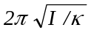 | –κθ = I(d²θ/dt²); ω ² = κ/I, where I = 1.71×10^{–3} kg.m²  ω ² = (κ + μB)/I = 4π ²/T ²; T ² = 4π ²I/(κ + μB)  κ = 0.246 N.m/rad  T = 0.523 s

106 ·· A long, narrow bar magnet that has magnetic moment μ parallel to its long axis is suspended at its center as a frictionless compass needle. When placed in a magnetic field B, the needle lines up with the field. If it is displaced by a small angle θ, show that the needle will oscillate about its equilibrium position with frequency f = (1/2)π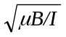, where I is the moment of inertia about the point of suspension.
From Equ. 28-15, the torque on the needle is τ= μ×B. If θ is small, sin θ ≈ θ and τ= –μBθ, the minus sign indicating that τis a restoring torque. From Equ. 9-20, τ= I(dθ ²/dt²), so the equation of motion for μ is
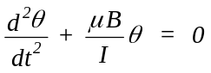. This is the harmonic oscillator equation of motion (see Equ. 14-25). The angular frequency is
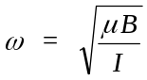 and the frequency of oscillation is 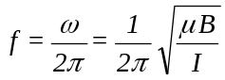; Q.E.D.

107 ·· A small bar magnet of mass 0.1 kg, length 1 cm, and magnetic moment μ = 0.04 A⋅m² is located at the center of a 100-turn loop of 0.2 m diameter. The loop carries a current of 5.0 A. At equilibrium, the bar magnet is aligned with the field due to the current loop. The bar magnet is given a displacement along the axis of the loop and released. Show that if the displacement is small, the bar magnet executes simple harmonic motion, and find the period of this motion.
We shall do this problem for the general case of a magnetic moment μ in a coil of N turns. The magnetic field B along the axis of the coil is given by Equ. 29-5 multiplied by N. The potential energy of μ is
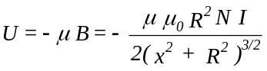 and the force on μ when displaced along x is 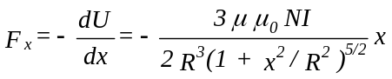.
For x << R, 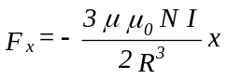. The equation of motion of μ is therefore 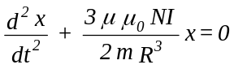. This is the
equation of motion for a harmonic oscillator of period 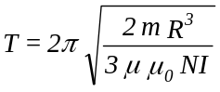 (see Equs. 14-2, 14-11).
Substituting the appropriate numerical values one obtains T = 10.2 s

108 ·· Suppose the needle in Problem 106 is a uniformly magnetized iron rod that is 8 cm long and has a cross-sectional area of 3 mm². Assume that the magnetic dipole moment for each iron atom is 2.2μ_{B} and that all the iron atoms have their dipole moments aligned. Calculate the frequency of small oscillations about the equilibrium position when the magnetic field is 0.5 G.
1. Find the number of iron atoms; N = N_{A}ρ V/ M  2. Find μ = 2.2Nμ_{B}  3. Find the moment of inertia, I (see Table 9-1)  4. Use the result of Problem 106; B = 0.5×10^{–4} T | N = 6.02×10²³ ×7.96×0.24/55.9 = 2.057×10²²  μ = 0.42 A.m²  I = (1.91×10^{–3} ×64×10^{–4}/12) kg.m² = 1.02×10^{–6} kg.m²  f = 0.722 Hz

109*·· The needle of a magnetic compass has a length of 3 cm, a radius of 0.85 mm, and a density of 7.96×10³ kg/m³. It is free to rotate in a horizontal plane, where the horizontal component of the earth's magnetic field is 0.6 G. When disturbed slightly, the compass executes simple harmonic motion about its midpoint with a frequency of 1.4 Hz. (a) What is the magnetic dipole moment of the needle? (b) What is the magnetization M? (c) What is the amperian current on the surface of the needle? (See Problem 106.)
(a) 1. Find I = mL²/12; m = ρπr²L; I = ρπr²L³/12  2. f = (1/2π)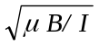; μ = 4π²f ²I/B  (b) M = μ/V = μ/πr²L  (c) I_{Amp} = M ΔL | I = 4.065×10^{–8} kg.m²  μ = 5.24×10^{–2} A.m²  M = 7.70×10⁵ A/m  I_{Amp} = 2.31×10⁴ A

110 ·· An iron bar of length 1.4 m has a diameter of 2 cm and a uniform magnetization of 1.72×10⁶ A/m directed along the bar's length. The bar is stationary in space and is suddenly demagnetized so that its magnetization disappears. What is the rotational angular velocity of the bar if its angular momentum is conserved? (Assume that Equation 29-27 holds where m is the mass of an electron and q = –e.)
1. Use Equ. 29-27 and 29-18 (μ = M_{s}V)  2. Find I  3. Set Iω = L and solve for ω  4. Evaluate ω | L = (2m_{e}/e)(πr² M_{s})  I = mr²/2 = ρπr⁴ /2  ω = 4m_{e}M_{s}/ρer²  ω = 4.92×10^{–5} rad/s

111 ·· The magnetic dipole moment of an iron atom is 2.219 μ_{B}. (a) If all the atoms in an iron bar of length 20 cm and cross-sectional area 2 cm² have their dipole moments aligned, what is the dipole moment of the bar? (b) What torque must be supplied to hold the iron bar perpendicular to a magnetic field of 0.25 T?
(a) See Problem 108; μ = 2.219μ_{B}N_{A}ρV/ M | μ = (2.219×9.27×10^{–24}×6.02×10²³×7.96×40/55.9) A.m²  = 70.5 A.m²

(b) τ= μ×B; here θ = 90º, so τ= μB | τ= 17.6 N.m

112 ·· A relatively inexpensive ammeter called a tangent galvanometer can be made using the earth's field. A plane circular coil of N turns and radius R is oriented such that the field B_{c} it produces in the center of the coil is either east or west. A compass is placed at the center of the coil. When there is no current in the coil, the compass needle points north. When there is a current I, the compass needle points in the direction of the resultant magnetic field B at an angle θ to the north. Show that the current I is related to θ and the horizontal component of the earth's field B_{e} by
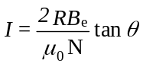
Since B_{e} and B_{c} are at right angles, tan θ = B_{c}/B_{e}. The field B_{c} is given by Equ. 29.4 (multiplied by N); so,
B_{c} = μ₀NI/2R = B_{e} tan θ. Solving for I one obtains I = (2RB_{e} /μ₀N)tan θ.

113*·· An infinitely long, straight wire is bent as shown in Figure 29-56. The circular portion has a radius of 10 cm with its center a distance r from the straight part. Find r such that the magnetic field at the center of the circular portion is zero.
1. Let R be the radius of the loop; write B_{loop}  2. Write B_{line} for infinite line  3. Note that B_{line} is opposite to B_{loop}; find r for B = 0 | B_{loop} = μ₀I/2R  B_{line} = μ₀I/2πr  r = R/π = 3.18 cm

114 ·· (a) Find the magnetic field at point P for the wire carrying current I shown in Figure 29-57. (b) Use your result from (a) to find the field at the center of a polygon of N sides. Show that when N is very large, your result approaches that for the magnetic field at the center of a circle.
(a) Note that only the current in the section of wire of length 2a contributes to the field at P. From Equ. 29-11,
B = (μ₀I/4πR)(2sin θ) = (μ₀I/2πR)sin θ, where sin θ = a/(a² + R²)^{1/2}.
(b) For an N-sided polygon, θ = π/N. Each side contributes to B an amount equal to that obtained in (a). Thus,
B = (μ₀NI/2πR)sin(π/N). In the limits N → ∞, sin(π/N) = π/N and B = μ₀I/2R.

115 ·· The current in a long, cylindrical conductor of radius R = 10 cm varies with distance from the axis of the cylinder according to the relation I(r) = (50 A/m)r. Find the magnetic field at (a) r = 5 cm (b) at r = 10 cm, and (c) r = 20 cm.
(a), (b), (c) Use Equ. 29-15 and cylindrical symmetry | (a), (b) B = (2×10^{–7} ×50) T = 1.0×10^{–5} T  (c) B = 5.0×10^{–6} T

116 ·· Figure 29-58 shows a square loop, 20 cm per side, in the xy plane with its center at the origin. The loop carries a current of 5 A. Above it at y = 0, z = 10 cm is an infinitely long wire parallel to the x axis carrying a current of 10 A. (a) Find the torque on the loop. (b) Find the net force on the loop.
(Note: In the first printing of the textbook, Figure 29-58 shows a loop current of 20 A, and the direction indicated for the current is opposite to that of the arrows on the loop. In the following we take I_{loop} = 5 A in the direction of the arrows on the loop.)
- The field B due to the 10-A current is in the yz plane. The net force on the wires of the square along the y direction cancel and do not contribute to a net torque or force. The magnitude of B at the the wire at x = 10 cm is B = (2×10^{–7}×10/0.141) T and B = (10^{–5} T)(–j – k); the field at the opposite wire is B = (10^{–5} T)(–j + k).The corresponding forces are obtained from Equ. 28–5; they are F = (10^{–5})[i×(–j) + i×(–k)] N = (10^{–5} N)(–k + j) and F = (10^{–5} N)(k – j). The force components in the y direction do not contribute to the torque. Those in the z direction give rise to a torque about the x axis equal to τ= (2×0.1×10^{–5}) N.m = 2×10^{–6} N.m.
(b) The net force on the loop is the sum of the forces on the four sides. Thus F_{net} = (2×10^{–5} N) –j.

117*·· In the Bohr model of the hydrogen atom, an electron in the ground state orbits a proton at a radius of
5.29×10^{–11} m. In a reference frame in which the orbiting electron is at rest, the proton circulates about the electron at a radius of 5.29 x 10^{–11} m with the same angular velocity as that of the electron in the reference frame in which the proton is at rest. Consequently, in the rest frame of the electron, the magnetic field due to the motion of the proton has the same magnitude as that calculated in Problem 5. The electron has an intrinsic magnetic moment of magnitude μ_{B}. Find the energy difference between the two possible orientations of the electron's intrinsic magnetic moment, either parallel or antiparallel to the magnetic field due to the apparent motion of the proton. (This energy difference is readily observed spectroscopically and is known as the fine structure splitting.)
ΔE = 2μ_{B}B; B = 12.5 T (see Problem 5) | ΔE = 2×9.27×10^{–24} ×12.5 J = 2.32×10^{–22} J = 1.45 meV

118 ·· The proton also has an intrinsic magnetic moment whose magnitude is 1.52×10^{–3}μ_{B}. The orientation of the proton's magnetic moment is quantized; it can only be parallel or antiparallel to the magnetic field at the location of the proton. Using the result of Problem 117, determine the energy difference of the hydrogen atom in the Bohr model for the two possible orientations of the proton's magnetic moment; neglect the magnetic field at the proton due to the electron's intrinsic magnetic moment. (This energy difference is referred to as hyperfine structure splitting.)
ΔE = 2μ_{p}B; B = 12.5 T, μ_{p} = 1.52×10^{–3}μ_{B} | ΔE = 3.52×10^{–25} J = 2.2×10^{–6} eV

119 ·· In the calculation of the hyperfine structure splitting in Problem 117, you neglected the magnetic field at the proton's position due to the intrinsic magnetic moment of the electron. Calculate the magnetic field due to the intrinsic magnetic moment of the electron at a distance of 5.29×10¹¹ m and compare its magnitude at the location of the proton with that due to the orbital motion of the electron. (Hint: Assume the electron spin is perpendicular to the plane of its orbit, and show that the magnitude of the magnetic field at a great distance from a magnetic dipole on a line perpendicular to the the dipole is given by B = (μ₀/4π)μ/r³.)

We begin by deriving the field along a line perpendicular to and at a great distance from the dipole. The adjacent figure shows the dipole and a point at a distance r from it. Here we have represented the dipole as two “magnetic poles” separated a distance 2a. Also shown are the fields produced by each pole. The magnitude of each field is B = (μ₀/4π)m/(a² + r²). It is evident that the y components of the two fields add and the x components cancel. The total field is | 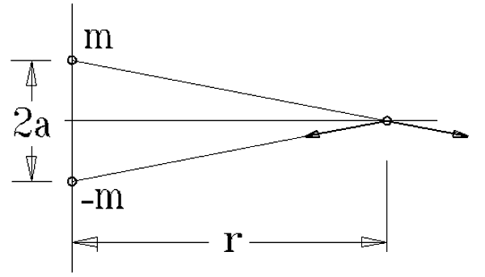

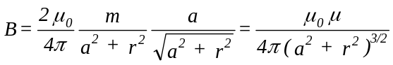, where μ = 2am is the magnetic moment of the dipole.
If r >> a, B = (μ₀/4π)μ/r³.
With μ = μ_{B} = 9.27×10^{–24} A.m² and r = a₀ = 5.29×10^{–11} m, B = [10^{–7} ×9.27×10^{–24}/(5.29×10^{–11})³] T = 6.25 T.
This is exactly half the field due to the electron’s orbital motion.

120 ··· A disk of radius R carries a fixed charge density σ and rotates with angular velocity ω. (a) Consider a circular strip of radius r and width dr with charge dq. Show that the current produced by this strip dI = (ω/2π) dq = ωσr dr. (b) Use your result from part (a) to show that the magnetic field at the center of the disk is B = μ₀σωR. (c) Use your result from part (a) to find the magnetic field at a point on the axis of the disk a distance x from the center.
(a) Once each period T = 2π/ω a total charge dq = 2πσrdr passes a given point. Given the definition of current,
I = Δq/Δt, the current in the element of width dr is dI = (2πσrdr)(ω/2π) = ωσrdr.
(c) The magnetic field dB_{x} at a distance x along the axis of the disk due to the current loop of radius r and width dr is
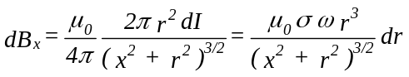. Integrating from r = 0 to r = R gives 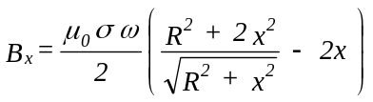.
(b) The field at the center of the disk is given by the preceding expression with x = 0: B = 1/2μ₀σωR.

121*··· A very long, straight conductor with a circular cross section of radius R carries a current I. Inside the conductor, there is a cylindrical hole of radius a whose axis is parallel to the axis of the conductor a distance b from it (Figure 29-59). Let the z axis be the axis of the conductor, and let the axis of the hole be at x = b. Find the magnetic field B at the point (a) on the x axis at x = 2R, and (b) on the y axis at y = 2R. (Hint: Consider a uniform current distribution throughout the cylinder of radius R plus a current in the opposite direction in the hole.)
We apply the Hint and use the following notation. Let I_{t} be the total current that would flow into the paper. Let I_{o} be the current that would then have to flow out of the paper in the region of the hole so that the net current in the conductor is I_{i}. We assume uniform current density J.
(a) 1. Write I_{i}, I_{o}, and I_{t} in terms of J  2. Use Equ. 29-12 and right-hand rule to find B  (b) 1. Find B_{t} = B due to I_{t} at y = 2R  2. Find B_{o} at y = 2R and its x and y components  3. Find B = B_{t} + B_{o} | I_{i} = Jπ(R² – a²); I_{t} = πR²J = 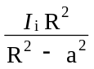; I_{o} = πa²J =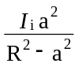0  B = 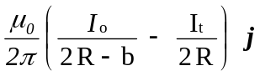 =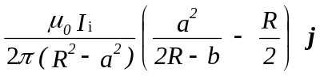  B_{t} = 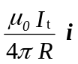  B_{o} = 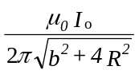; B_{ox} = –B_{o}cos θ = –B_{o}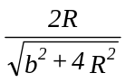;  B_{oy} = –B_{o}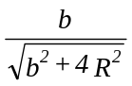  B = 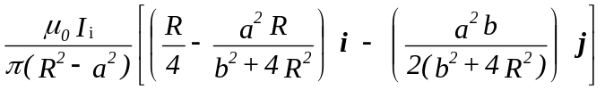

122 ··· For the cylinder with the hole in Problem 121, show that the magnetic field inside the hole is uniform, and find its magnitude and direction.

We will use the same notation as in Problem 121 and determine the field B at an arbitrary point with coordinates (x, y) inside the cylindrical hole. The geometry is shown in the figure. The fields B_{o} and B_{t} are those arising from the currents I_{o} and I_{t}, respectively. The distance r₁ and r₂ are those from the origin to the point of interest and from (b, 0) to the point of interest, respectively. Using Ampère’s law and the expressions for I_{t} and I_{o} of the preceding problem, the magnitudes of these fields are 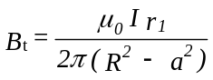 and 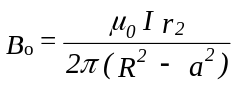, where we have set I_{i} = I. | 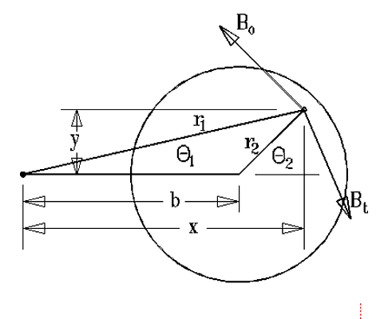
The x and y components of these fields are given by B_{tx} = B_{t} sin θ ₁, B_{ty} = –B_{t} cos θ ₁, B_{ox} = –B_{o} sin θ₂ and B_{oy} = B_{o} cos θ ₂. These trigonometric functions are given by sin θ ₁ = y/r₁ , cos θ ₁ = y/r₁, sin θ ₂ = y/r₂, and cos θ ₂ = (x – b)/r₂. Evidently, the x components sum to zero. The sum of the y components gives
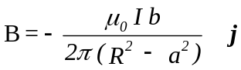 which is independent of x and y.

123 ··· A square loop of side lies in the yz plane with its center at the origin. It carries a current I. Find the magnetic field B at any point on the x axis and show from your expression that for x much larger than ,
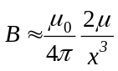
where μ = I ² is the magnetic moment of the loop.
From the symmetry of the system it is evident that the fields due to each segment of length are the same in magnitude. The sine of the angle between the line from (x, 0, 0) to (0, 1/2, 0) and the line from (x, 0, 0) to
(0, 1/2l, 1/2) is (/2)/(x² + ²/2)^{1/2}. Thus the magnitude of the field due to one segment is (see Equ. 29-11)
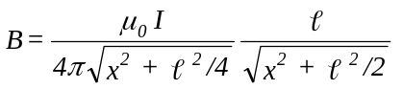. By symmetry, the sum of the y and z components of the fields due to the four segments must vanish, whereas the x components will add. Thus, 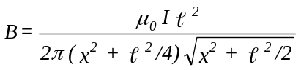. In the limit x >> , the denominator reduces to x³ and B = μ₀μ/2πx³, where μ = I ².

124 ··· A circular loop carrying current I lies in the yz plane with its axis along the x axis. (a) Evaluate the line integral along the axis of the loop from x = –₁ to x = +₁. (b) Show that when ₁ → ∞, the line integral approaches μ₀I. This result can be related to Ampère's law by closing the curve of integration with a semicircle of radius on which B ≈ 0 for very large.

(a), (b) From Equ. 29-5, 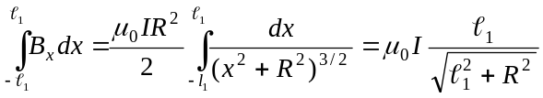. In the limit ₁ >> R, B_{x} = μ₀I.

125*··· The current in a long cylindrical conductor of radius R is given by 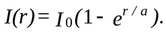 Derive expressions for the magnetic field for r < R and for r > R.
For r < R , B = (μ₀I₀/2πr)(1 – e^{–r/a}); for r > R, B = (μ₀I₀/2πr)(1 – e^{–R/a}).

126 ··· In Example 29-8 we calculated the magnetic field inside and outside a wire of radius R carrying a uniform current I. Consider a filament of current at a distance r from the center of the wire. Show that this filament experiences a force directed toward the center of the wire and that, therefore, the current distribution cannot be truly uniform. This so-called pinch effect depends on the magnitude of the current, but is generally negligibly small. Consider a copper wire of 2.0 cm diameter that carries a nominally uniform current of 400 A. Calculate the force per meter exerted on a 0.1-mm-thick annular region of current at the periphery of the wire. Assume that the current is carried by the conduction electrons. How far toward the center of the wire would this annular current region have to move so that the electrostatic force between the electrons and the fixed positive ions at the periphery just balances the magnetic force?
Within a radius r < R, the current is I(r) = (r²/R²)I. By Ampère’s law, B(r) = (μ₀Ir²)/(2πrR²) = (μ₀Ir)/(2πR²). Since the current within the radius r is parallel to the current filament at r, the two attract one another. Note that by Ampère’s law, the current in the annular region outside r does not produce a field at r.
For the copper wire of the problem, r ≈ 1.0 cm, R = 1.0 cm, I = 400 A. The current filament is 2πRΔrJ, here J is the current density, J = I/πR². The force per unit length on the current filament is obtained from Equ. 29-13, with I₁ = I and I₂ = 2ΔrI/R, where here Δr = 0.1 mm. With these values one obtains F/L = 6.4×10^{–4} N/m, directed toward the center of the wire.
The charge density of conduction electrons in copper is (see Table 27-1), ρ_{e} = –(8.47×10²² ×1.6×10^{–19}) C/cm³
= –1.36×10⁴ C/cm³ = –1.36×10¹⁰ C/m³. The charge per unit length in an annulus of width s at the radius R is λ = 2πRsρ_{e}. If that annulus is depleted of electrons by having them brought radially inwards the field acting on the positively charged annular region is E = 2kλ/R = 4πksρ_{e}, and the force per unit length on that annulus is Eλ = 8π²kρ_{e}²Rs². Equating this force to that due to the magnetic interaction one obtains s = 2.2×10^{–17} m, an insignificantly small distance (about one hundredth of a nuclear radius).

